Setting up Git Configuration in Jenkins Job

Step 1: Create new credentials in Jenkins for Git configuration

1.1 Log in to Jenkins using credentials

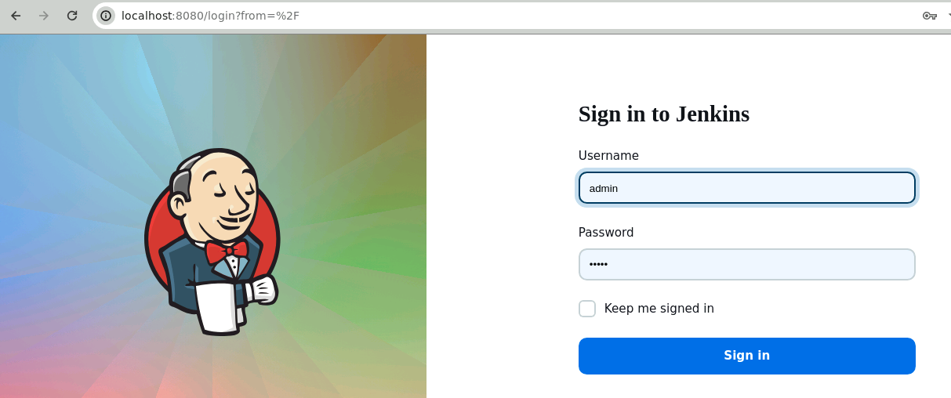

1.2 Navigate to Manage Jenkins and click on Credentials

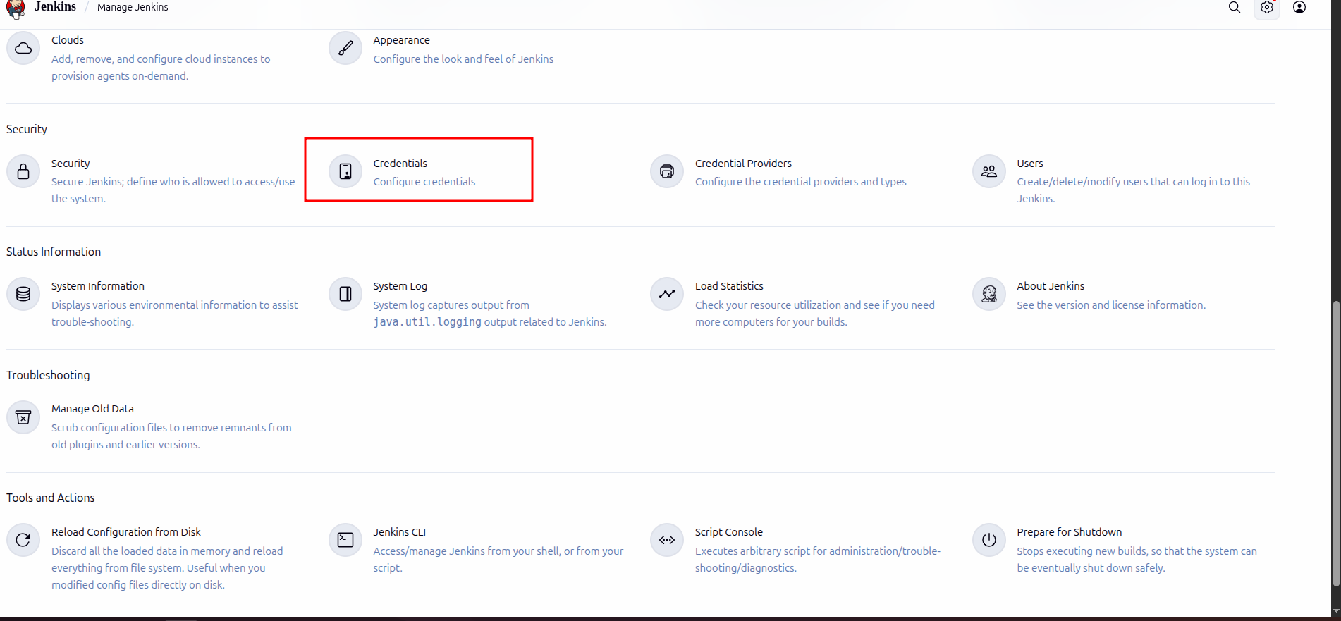

1.3 Click on System under Stores scoped to Jenkins and then click on Global credentials

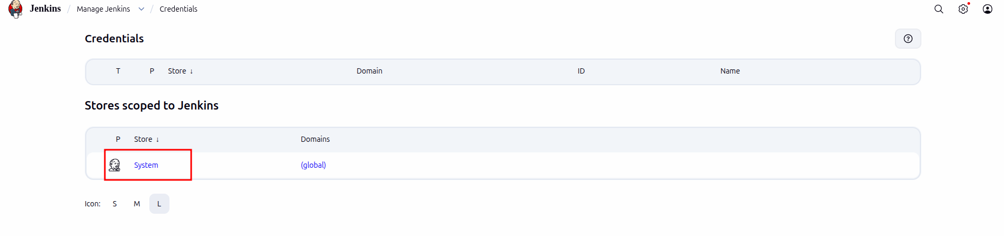

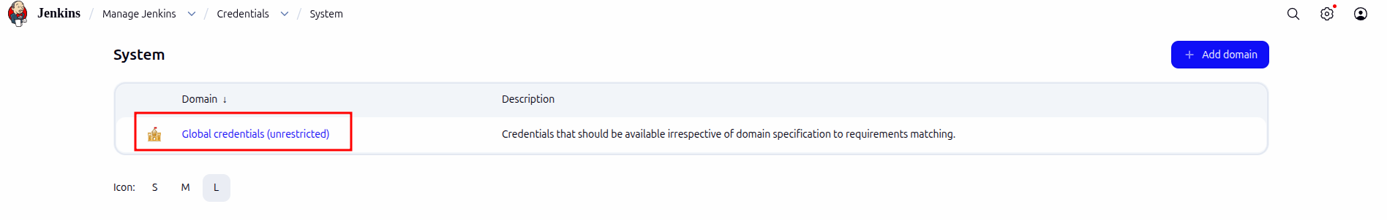

1.4 Click on + Add Credentials

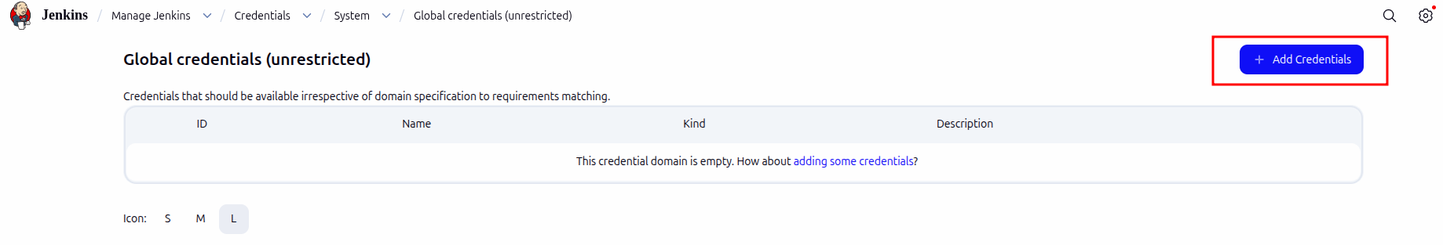

1.5 Under Kind, select the Username with password option

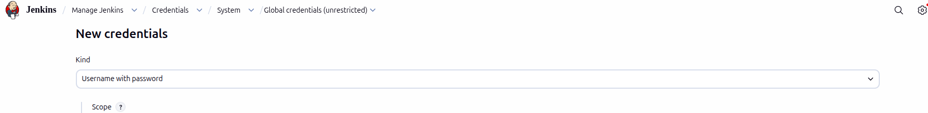
1.6 Add your GitHub Username and Password, assign Project as the ID, and click on Create

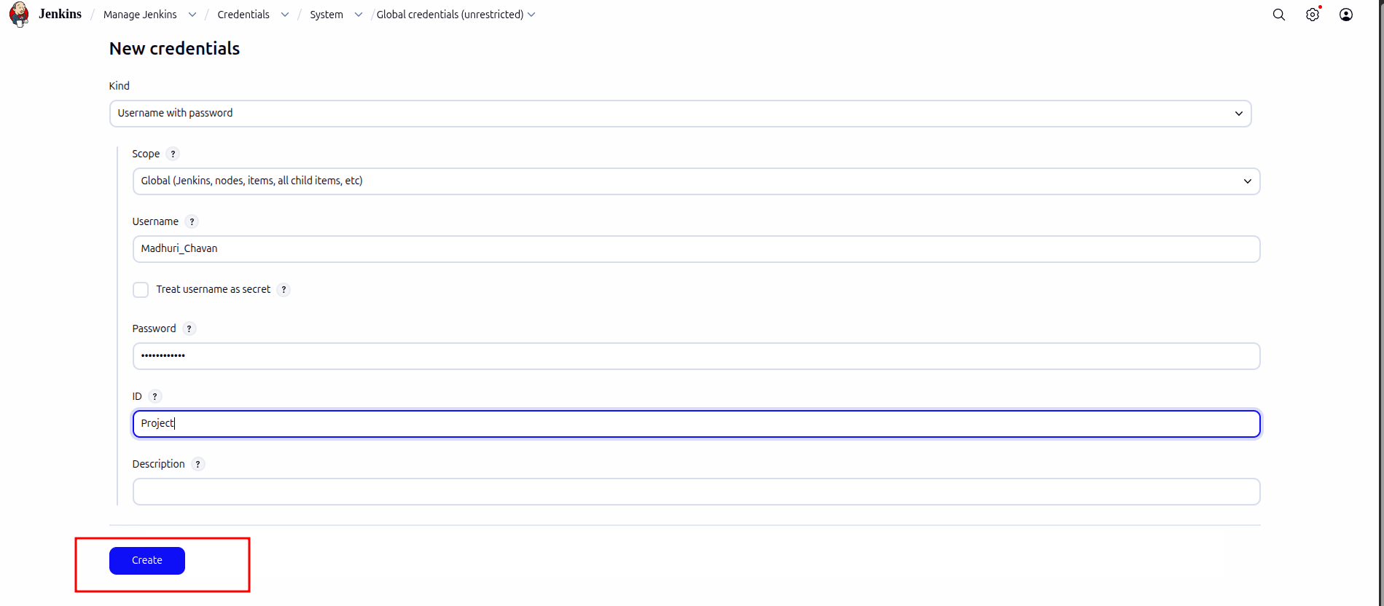

Step 2: Create a Jenkins freestyle project

  - On the Jenkins dashboard, click on + New Item
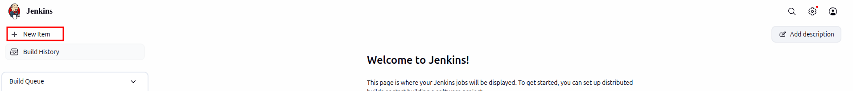

  - Enter the project name as 1_BuildProject, select the Freestyle project option, and click on OK



Step 3: Configure Git in Jenkins

3.1 Navigate to the General section, select This project is parameterized, click on Add Parameter, and select Credentials Parameter

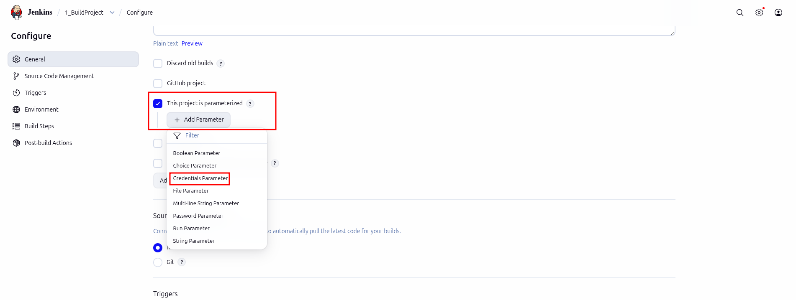
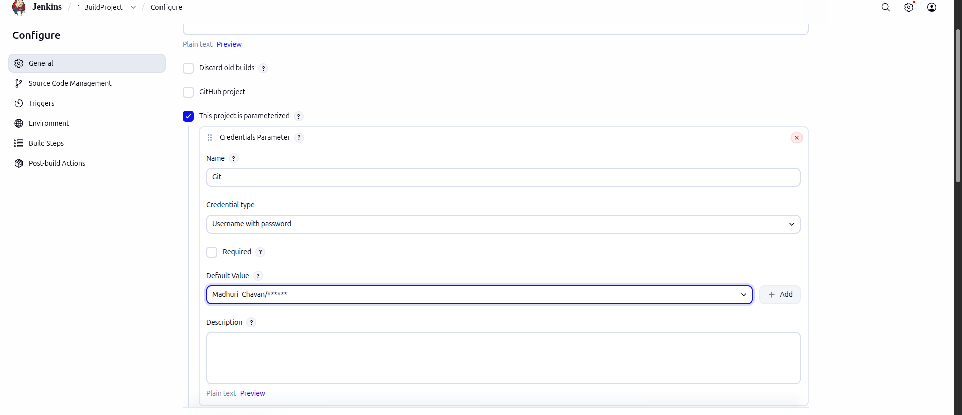
3.2 Add Name as Git, select Username with password as the Credential type, and then choose your created credentials as the Default value

3.3 Navigate to the Source Code Management section, provide the GitHub Repository URL, select the added GitHub credentials, and click Apply and Save

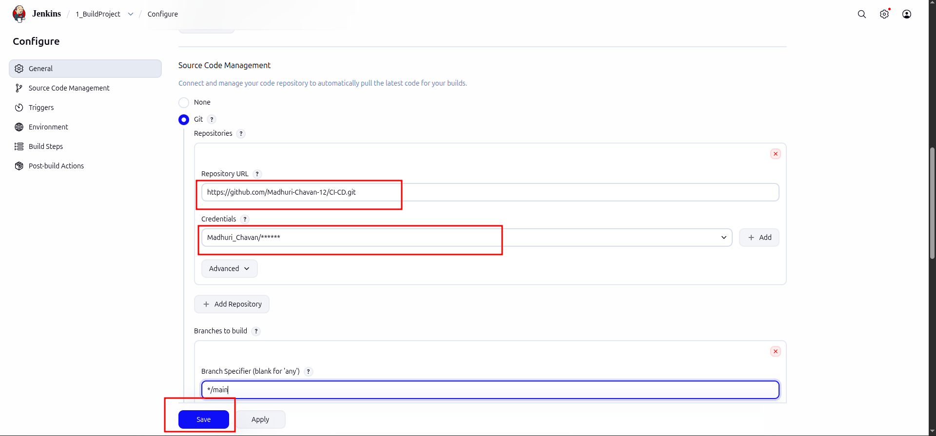
3.4 In the Jenkins dashboard, click on Build with Parameters under the Status, then click on Build
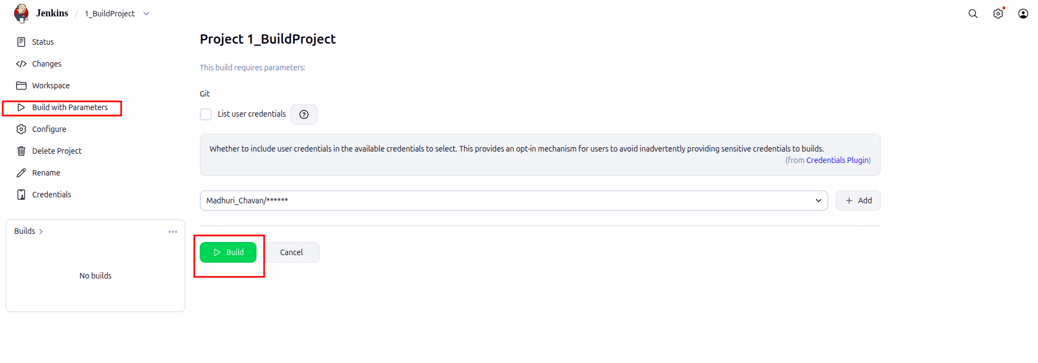

3.5 Click on Console Output to see the output

